Driving Commercial Growth: The Strategic Role of the Project Management Office (PMO) in Business Development
Mark Reeson
Executive Summary
In the modern corporate ecosystem, organizations face volatile, uncertain, complex, and ambiguous (VUCA) conditions. To survive and grow, companies must continually secure new commercial opportunities through effective business development. However, winning contracts is only half the battle; those contracts must be strategically aligned, financially viable, and practically deliverable.
Historically, the Project Management Office (PMO) has been viewed as an administrative function focused strictly on the execution of post-award activities. This white paper redefines that paradigm, positioning the PMO as a critical strategic enabler of pre-award business development. By integrating the structural frameworks of the Association for Project Management (APM) Body of Knowledge 7th edition, this paper demonstrates how a mature PMO enhances commercial win rates, eliminates optimism bias in bidding, optimizes resource utilization, and ensures that new corporate acquisitions directly support the organization's strategic intent.
Through robust governance frameworks, rigorous investment scrutiny, strategic sourcing alignment, and lifecycle tailoring, the PMO bridges the traditional organizational divide between the sales pipeline and operational reality. The practical models outlined herein provide executive leaders with a blueprint for transforming their PMO into an engine of sustainable business growth.
1. Introduction: The Evolving Landscape of Commercial Growth
Securing sustainable business development within modern commercial landscapes requires an organizational framework capable of balancing growth with governance. For decades, corporate entities have maintained a strict, siloed separation between business development (sales and bidding) teams and operational delivery structures. The former is typically incentivized by revenue acquisition, while the latter is measured against the rigid constraints of time, cost, quality, and risk management. This structural fragmentation frequently results in a phenomenon known as the ‘sales-to-delivery chasm,’ where organizations successfully win complex, high-value contracts that are fundamentally undeliverable or commercially unviable under real-world conditions.
As global markets become increasingly interconnected and volatile, this chasm is acutely visible in highly regulated, mission-critical sectors such as healthcare. When bidding on complex healthcare transformations—such as regional hospital infrastructure delivery, clinical system digitisations, or health authority restructuring programs—organizations face multi-layered challenges. These initiatives cannot be treated as isolated, discrete projects; rather, they demand a sophisticated program management approach capable of coordinating interdependent workstreams, managing cumulative clinical risks, and aligning diverse stakeholder groups (including clinicians, regulatory bodies, and public administrators).
Furthermore, operating within such high-stakes environments requires uncompromising governance. Organizations can no longer afford to pursue capital-intensive mega-projects or healthcare transformations through ad-hoc, emotion-driven bidding. The introduction of value-based healthcare delivery models, stringent regulatory compliance standards, and complex operational transitions necessitates a formalized, institutionalized review mechanism before any commercial commitment is made.
This white paper establishes the case for positioning the Project Management Office (PMO)—operating at an enterprise level as both a Project and Programme Management Office—at the centre of the pre-award business development phase. Far from being a mere administrative ledger or a post-facto reporting mechanism, a strategic PMO acts as the vital governance bridge that ensures every commercial pursuit is thoroughly qualified, accurately estimated, and strategically aligned with long-term corporate capabilities.
Using the foundational tenets of project, programme, and portfolio management as codified by the Association for Project Management (APM), alongside rigorous multi-tiered governance controls, we analyse how the PMO minimizes systemic commercial risks while maximizing overall bid profitability and operational readiness. In doing so, it equips organizations—particularly those navigating the complex regulatory landscapes of healthcare and public infrastructure—to transition safely from commercial aspiration to deliverable reality.
2. Theoretical Framework: Aligning Business Development with Strategic Intent
To understand the practical integration of the PMO into business development, it is first necessary to establish the theoretical relationship between commercial pursuits and organizational strategy. Commercial growth should not be pursued arbitrarily; rather, it represents the intentional investment of corporate capability to achieve a defined future state.

2.1 The Hierarchy of Strategic Intent
An organization’s vision and mission are realized through a continuous process of strategy formulation and strategy implementation. As illustrated in the APM framework, corporate strategy dictates the deployment of portfolio structures, which select, prioritize, and control change initiatives and commercial endeavours to optimize return on investment.
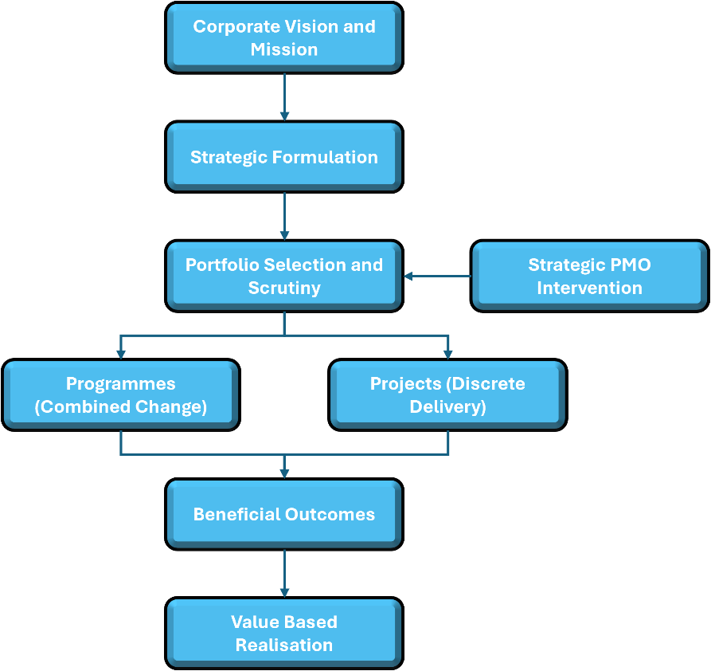
When business development activities operate outside this hierarchy, companies frequently bid on and secure contracts that divert critical resources away from the core corporate mission. For example, a specialized healthcare advisory firm focused on high-margin clinical governance might be lured into a low-margin, high-volume operational support contract for a regional hospital network due to its sheer top-line value. Without a portfolio and program management function to scrutinize this alignment, the investment can lead to resource stagnation, clinical capability strain, and long-term margin dilution.
Furthermore, in complex sectors like healthcare, commercial pursuits are rarely isolated, single-output projects. They typically manifest as large-scale programmes comprising multiple interdependent projects—such as concurrent clinical technology upgrades, physical facility expansions, and workforce upskilling.
- Programmatic Complexity: The strategic PMO ensures that the pre-award business case does not evaluate a bid as a standalone delivery piece but rather assesses how the opportunity fits within an overarching programme of change.
- Governance Scrutiny: By applying rigorous governance controls at the portfolio entry point, the PMO evaluates whether the organization possesses the programmatic maturity and clinical safety frameworks required to manage multi-workstream delivery without compromising ongoing operational care.
2.2 Moving from Delivery Culture to an Ethos of Value
Traditional commercial bidding focuses heavily on the ‘Iron Triangle’ or the triple constraints of time, cost, and quality. While these metrics remain foundational, contemporary management by projects and programmes acknowledges that long-term commercial success—especially in complex domains like healthcare—depends on an overarching ‘ethos of value’ and structured benefits realization.
In a healthcare delivery context, promising to build a hospital facility on time and within budget (the output) is no longer a sufficient commercial proposition. Clients, health authorities, and regulatory bodies demand proof that the initiative will deliver sustainable health outcomes, improved clinical safety, and long-term operational efficiency. The strategic PMO shifts the pre-award focus from merely promising an output to defining and securing a sustainable business case centred on outcomes and multi-layered benefits. A benefit is defined as a positive and measurable impact of change. Through rigorous governance and programme management oversight, the PMO ensures that commercial proposals clearly articulate how these systemic benefits will be achieved, transforming the organization from a transactional vendor into a trusted value-driven partner.
Traditional Sales Bidding Approach | PMO-Led Strategic Value Bidding Approach
Focuses primarily on top-line contract value and revenue acquisition. | Focuses on net profit margins, portfolio alignment, and resource capability.
Optimistic estimations based on standard product/service baselines. | Empirical estimations utilizing historical data and risk-adjusted baselines.
Handover occurs abruptly at contract signature, creating delivery silos. | Continuous integration from initial concept, through definition, to deployment.
Assumes stable client requirements and linear operational environments. | Formulates flexible, hybrid lifecycles to accommodate client uncertainty.

3. The Strategic PMO as an Enabler of Commercial Success
The structural configuration of a PMO dictates its ability to influence business development outcomes. The APM Body of Knowledge identifies that PMOs exist in various forms, ranging from localized project support offices to enterprise-wide strategic portfolios. To effectively drive business development, the PMO must operate at an enterprise or strategic level, acting as a permanent organizational function rather than a temporary project structure.
3.1 Managing the Pipeline as a Strategic Portfolio
A mature business development pipeline is a portfolio of high-risk options. Each bid represents a deployment of capital expenditure (Capex) and operating expense (Opex) via bid budgets, specialized staff time, and legal resources. The strategic PMO applies formal portfolio management key processes to this pipeline:
- Sizing for Efficiency and Capacity: The PMO continuously monitors resource availability across the entire permanent organization. Before the company commits to an intensive tendering process, the PMO evaluates whether the organization possesses the capacity bottlenecks that could impair the future delivery of the contract.
- Balancing Risks and Returns: Not all bids carry the same risk profile. The PMO uses portfolio balancing techniques to ensure that the commercial pipeline contains an optimal mix of high-risk/high-return speculative bids and low-risk/stable revenue operations, preventing corporate over-exposure to catastrophic delivery failures.
- Interdependency Management: Large commercial contracts rarely exist in isolation. The PMO maps out how a prospective bid might conflict with or complement ongoing internal change initiatives, shared technical infrastructure projects, or existing client relationships.
"By acting as the custodian of corporate capacity, the strategic PMO prevents the sales function from overselling the organization’s capability, ensuring that every contract won can be executed to the client's satisfaction without eroding internal operational stability."

4. Governance, Investment Scrutiny, and Bid Qualification
The establishment of rigorous governance and oversight mechanisms represents the first line of defence against unprofitable or undeliverable commercial acquisitions. Bid qualification, the decision-making process governing whether an organization should pursue a commercial opportunity is often compromised by emotional investment or organizational pressure to meet sales quotas.
4.1 Mitigating Planning Fallacy and Optimism Bias
Corporate finance and project management literature extensively document the risks of ‘planning fallacy’ and ‘optimism bias,’ where executive decision-makers spin scenarios of success while overlooking the potential for mistakes, miscalculations, and systemic delivery overruns. In business development, this manifests as hyper-competitive pricing based on ideal operational assumptions.
The PMO counteracts this bias by implementing independent investment scrutiny. It introduces structured financial and non-financial metrics to evaluate the investment case long before a formal proposal is submitted to a client:
- Net Present Value (NPV) & Internal Rate of Return (IRR): The PMO models the prospective contract's cash flows over its full economic life cycle, accounting for the weighted average cost of capital (WACC) and long-term operational maintenance costs, rather than merely evaluating the initial contract signature value.
- Hurdle Rate Adherence: The PMO enforces adherence to corporate hurdle rates, ensuring that the estimated profit margin of a prospective project exceeds the minimum target return required to justify the deployment of corporate capital.
- Maturity of Definition Assessments: The PMO assesses the clarity of the client's request for proposal (RFP). If the scope is poorly defined, the PMO introduces a higher risk premium into the financial model, protecting the company against unexpected margin erosion during execution.
4.2 Implementing the 5-Case Business Model for Major Bids
For major commercial opportunities, particularly in complex sectors like healthcare, the PMO should mandate the structuring of the internal bid justification using a comprehensive multi-dimensional framework. Borrowing from standard five-case governance models, the PMO requires the bid team to explicitly prove five core dimensions before approving a submission:

The 5-Case Business Bid Model
Strategic | Does this opportunity align with our corporate vision?
Economic | Does the financial return justify the delivery risk?
Commercial | Is our sourcing strategy viable for the supply chain?
Financial | Do we have the cash flow capacity to fund mobilization?
Management | Do we have the talent and lifecycle tools to deliver?

By institutionalizing this level of rigorous governance, the PMO ensures that the business case for pursuing a bid is built on empirical data and compliance structures rather than executive intuition.
5. Lifecycle Tailoring in Business Development: From Proposal to Transition
A foundational error in business development is treating the bidding process as a purely creative or sales-driven exercise, divorced from standardized execution lifecycles. A strategic PMO introduces the concept of ‘lifecycle philosophy’ into pre-award activities, ensuring that the proposed delivery methodology perfectly matches the client’s risk appetite and environmental uncertainty.
5.1 Linear vs. Iterative Bidding Strategies
The PMO plays a vital role in analysing whether a prospective commercial contract or major programme should be delivered via a linear, iterative, or hybrid lifecycle framework:
- Linear Lifecycles for Stable Scopes: For highly stable, low-risk, and well-understood scopes of work—such as standardized clinical facility construction or routine medical equipment fit-outs—the PMO structures the proposal around a rigid sequence: Concept, Definition, Deployment, and Transition. Under strict governance controls, this allows for a fixed-price contract model that offers maximum predictability and tight cost control for both the healthcare provider and the client.
- Iterative and Adaptive Lifecycles for Healthcare Innovation: When bidding on complex healthcare transformations, digital health record integrations, or value-based care models, clinical requirements and regulatory parameters are rarely static. Forcing a rigid linear model on an uncertain healthcare scope can lead to severe operational friction, compliance failures, and catastrophic contract disputes. Here, the PMO designs a proposal built on iterative principles, utilizing prototyping, timeboxes, and parallel development streams. The commercial structure is tailored to focus on progressive elaboration, allowing clinical workflows to evolve safely through stakeholder feedback while protecting profit margins through adaptive commercial clauses.
5.2 Designing the Hybrid Advantage
In contemporary commercial environments, clients increasingly demand a combination of speed-to-market and strict financial accountability. To meet this demand, the PMO designs a hybrid lifecycle model within the commercial proposal.
For instance, during a major public sector modernization bid, the PMO may mandate that the early requirements gathering and stakeholder engagement phases utilize highly collaborative, iterative agile methods to reduce ambiguity and secure user buy-in. Conversely, the core system deployment and physical rollout phases are locked into a linear, sequential stage-gate sequence. This hybrid design gives the sales team a competitive differentiator: it demonstrates to the client that the company possesses the agility to innovate alongside the corporate governance required to control expenditures and mitigate systemic delivery failures.
6. Strategic Sourcing and Ecosystem Collaboration in Bidding
Modern business development is rarely a solo endeavour; winning complex contracts requires assembling an ecosystem of partners, niche subcontractors, and technology vendors. The PMO ensures that the commercial team does not approach the supply chain in an ad-hoc or purely transactional manner.
6.1 Pre-Award Supply Chain Segmentation
Modern business development is rarely a solo endeavour; winning complex contracts requires assembling an ecosystem of partners, niche subcontractors, and technology vendors. In high-stakes sectors like healthcare, the PMO ensures that the commercial team does not approach the supply chain in an ad-hoc or purely transactional manner but instead applies rigorous governance and programme management oversight to evaluate external dependencies before a bid is submitted.
The PMO applies the Kraljic matrix framework to analyse the prospective contract’s delivery requirements across multi-workstream programmes. By categorizing required external resources into Routine, Leverage, Bottleneck, and Strategic quadrants, the PMO guides the business development team on how to structure partner agreements and clinical supply chains:

High | Low | High
Profit/Impact | Leverage Items  Invoke high competition  Maximize unit cost savings | Strategic Items  Form long-term partnerships  Share risk/reward metrics
Profit/Impact | Non-Critical Items  Streamline procurement  Minimize administrative overheads | Bottleneck Items  Secure volume insurance  Lock in long-term supply
Low | Supply Risk

When bidding on a major healthcare contract that requires scarce, high-risk technical assets—such as specialized diagnostic medical imaging technology, pharmaceutical cold-chain logistics, or rare clinical specialist staffing (classified as Bottleneck or Strategic items)—the PMO prevents the business development team from assuming these assets can be easily acquired on the open market post-award. Instead, under strict governance controls, it mandates the formalization of exclusive pre-bid alliances, clinical vendor vetting, and joint-venture frameworks to safeguard patient safety and operational delivery.
6.2 Balancing Principal Contractor Risks
Many organizations choose to win bids by acting as a principal contractor, managing second- and third-tier suppliers on behalf of the client. While this model drives significant scale, it exposes the organization to massive vicarious liability.
The PMO injects robust contract management controls into the pre-award phase. It ensures that the back-to-back legal obligations, performance guarantees, and risk drawdown provisions are mirrored from the primary client contract down into the subcontractor agreements. This strategic alignment optimizes buying advantages and safeguards corporate profitability against supplier defaults.
7. Talent Management and High-Performing Bid Teams
Winning high-value commercial pursuits depends on human capability. Business development requires a unique synthesis of strategic thinking, technical mastery, and financial acumen. The PMO plays a vital role in executing a resource-based view of the firm, treating internal talent as a core competency that must be carefully audited, deployed, and supported.

7.1 Cross-Functional Resource Mobilization
The process of assembling a bid team involves establishing a temporary organization. This temporary structure draws heavily on the permanent staff of the organization, cross-functionally mobilizing experts from legal, finance, engineering, operations, and human resources.
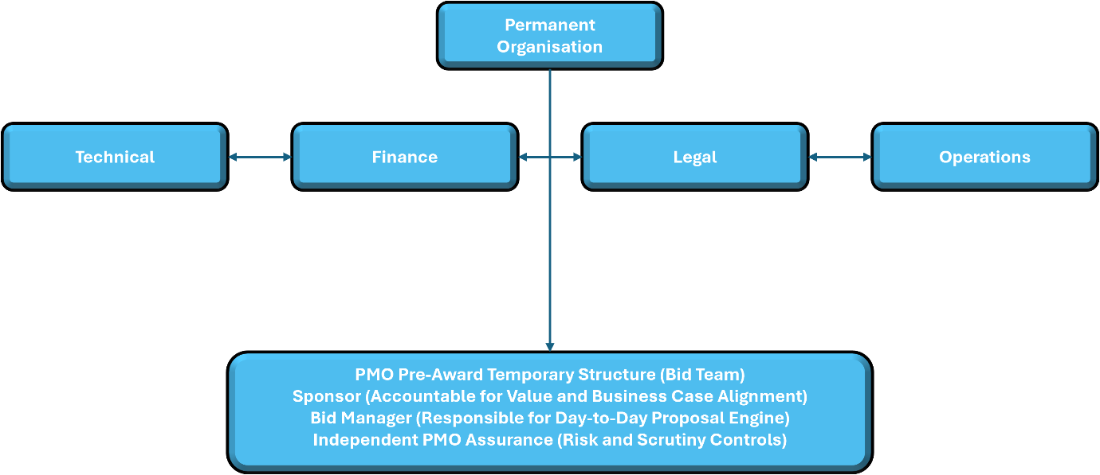
The PMO ensures that this temporary alignment does not create organizational friction or diminish the performance of ongoing operations. By acting as a central clearinghouse for talent, the PMO evaluates the competency profiles of available personnel, ensuring that the specific technical challenges of a prospective contract are addressed by professionals with matching capabilities.
7.2 Succession Planning and Knowledge Transfer
Participating in high-value business development opportunities is a primary vehicle for professional development. A mature PMO utilizes talent management practices to ensure that junior engineers, analysts, and project managers are embedded within pre-award bid structures alongside seasoned executives. This conscious integration drives a variety of systemic advantages:
- Generating Business Awareness: Technical professionals gain a comprehensive understanding of commercial risk, client negotiation, and pricing strategies, making them more effective deliverers post-award.
- Preventing Knowledge Boundaries: Knowledge silos frequently form between bid writers and execution teams. Involving delivery professionals in the pre-award phase ensures that historical project data, lessons learned, and execution realities are integrated into the new proposal, eliminating systemic estimation errors.
8. Independent Assurance, Decision Gates, and Risk Mitigation
The ultimate value of a PMO in business development is expressed through its ability to provide objective, independent confidence to executive boards that a prospective contract is viable. To achieve this, the PMO establishes an integrated assurance framework built on the Three Lines of Defence model.
8.1 The Three Lines of Defence in Bid Management
The ultimate value of a PMO in business development is expressed through its ability to provide objective, independent confidence to executive boards that a prospective contract or complex programme is viable. To achieve this—particularly within highly regulated, risk-sensitive environments like healthcare—the PMO establishes an integrated assurance framework built on the Three Lines of Defence model:
- First Line (Management Controls): The primary bid team conducts self-assessments, ensuring that basic client compliance criteria, baseline cost estimates, clinical safety prerequisites, and qualitative descriptions meet standard organizational requirements.
- Second Line (PMO Oversight & Quality Assurance): The PMO conducts independent, risk-based reviews under rigorous governance protocols. PMO analysts examine pricing models, challenge baseline assumptions, check historical cost data from past delivery failures, and ensure that appropriate levels of contingency have been held for known and unknown threats, such as clinical regulatory shifts or supply chain disruptions.
- Third Line (Independent Peer Review & Internal Audit): For ultra-high-value strategic pursuits or large-scale healthcare transformations, the PMO coordinates independent peer reviews led by senior directors, clinical safety officers, or external consultants completely disconnected from the bid's financial success. This ensures absolute neutrality, verifies compliance with statutory standards, and eliminates any potential conflicts of interest or executive cognitive bias prior to submission.
8.2 Implementing Mandatory Decision Gates
The PMO enforces control over the business development lifecycle by instituting non-negotiable Decision Gates (also known as stage-gates or phase-reviews). In complex sectors like healthcare, a bid or major programme proposal cannot progress to the next stage of expenditure without receiving formal, documented authorization from the governance board or designated executive sponsor.
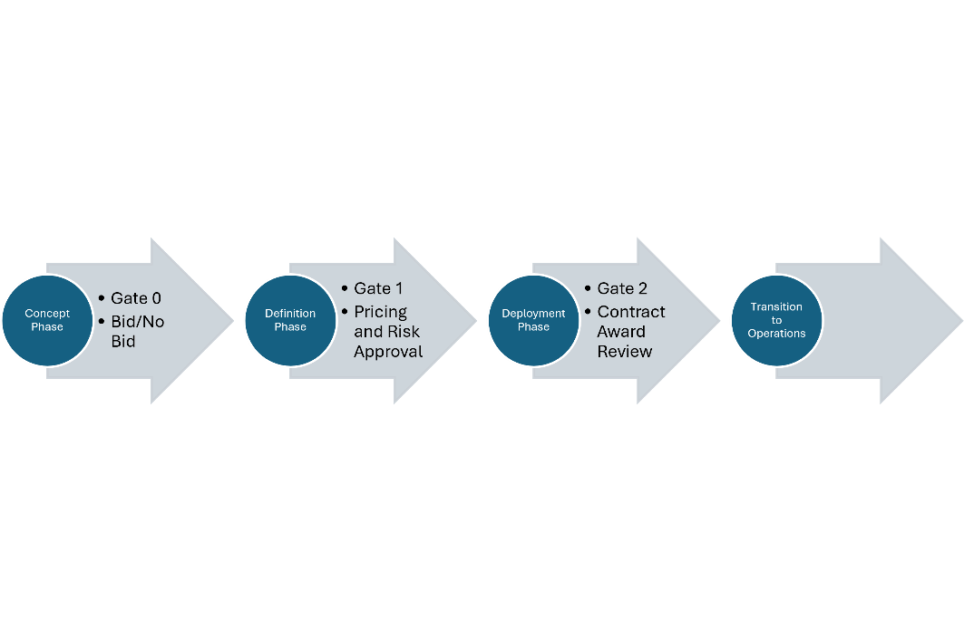
- Gate 0 (Bid / No-Bid): Conducted at the end of the initial concept phase. The PMO reviews the outline business case, strategic alignment, and initial clinical or operational risk profiles. If the opportunity does not fit corporate capabilities, regulatory standards, or long-term strategy, it is terminated immediately, saving valuable bid budget.
- Gate 1 (Pricing & Risk Approval): Conducted prior to final proposal submission. The PMO reviews the detailed deployment baseline, resource optimization schedules, and cost planning provisions under strict governance oversight. The bid team must prove that the pricing model includes robust contingency management protocols for clinical compliance shifts, regulatory hurdles, and supply chain disruptions.
- Gate 2 (Contract Award Review): Conducted post-win but pre-execution. The PMO facilitates the formal handover from the temporary bid organization to the permanent or temporary operational delivery team, ensuring that all pre-award assumptions, clinical safety protocols, stakeholder maps, and risk structures are perfectly preserved.

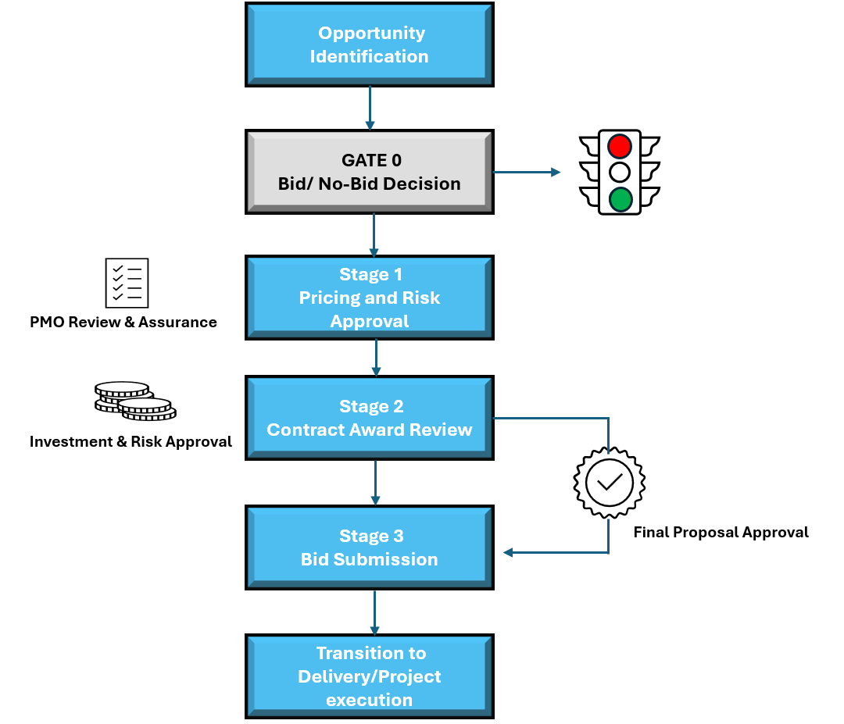

9. Holistic Value: Incorporating Sustainability and Long-Term Operations
Modern corporate governance mandates that commercial growth cannot occur at the expense of environmental, social, or economic sustainability. Increasingly, global public and private sector clients—particularly within mission-critical sectors like healthcare—place significant scoring weight on sustainability criteria, clinical safety, and long-term asset resilience within their procurement processes. A strategic PMO gives business development teams a competitive advantage by embedding long-term sustainability, strict governance, and full product lifecycle thinking into the core of every proposal.
9.1 The Triple Bottom Line as a Competitive Differentiator
When bidding on complex contracts and major programmes, the PMO ensures that the value proposition explicitly accounts for the ‘Triple Bottom Line’, balancing environmental stewardship, social responsibility, and economic affordability.
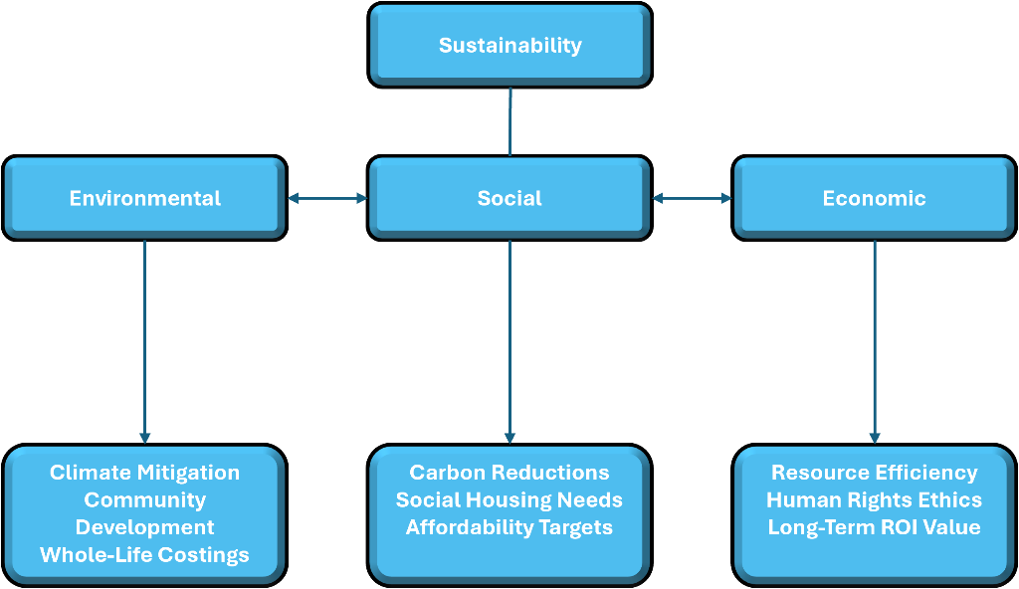
The PMO requires the bid team to think beyond the immediate delivery of the asset and evaluate its full lifecycle footprint. In healthcare infrastructure, medical technology integration, or clinical services, this involves presenting a comprehensive plan for whole-life costing, demonstrating that the company’s solution is not just cost-effective to install, but highly affordable, safe, and efficient to maintain, operate, and eventually decommission.
By providing detailed calculations regarding carbon reduction, energy efficiency, clinical safety compliance, and social value metrics (such as utilizing local healthcare talent or supporting community health initiatives), the PMO elevates the commercial proposal above purely price-driven competition.
9.2 Eliminating the Knowledge Gap in Product Stewardship
When a company wins a contract to build and operate a healthcare infrastructure asset or digital clinical platform, the project eventually transitions from deployment into long-term operations and ultimate termination. If the business development team does not plan for this transition under disciplined governance and programme management oversight, massive financial and clinical penalties can occur during the handover phase.
The PMO enforces product stewardship principles during the pre-award stage. It ensures that operational guidelines, clinical continuity protocols, decommissioning complexities, and environmental liabilities are fully accounted for within the commercial terms. This ensures that the organization protects its long-term corporate reputation, safeguards patient safety, and avoids value erosion over the full economic life of the contract.
10. Practical Roadmap for Implementation
The integration of the Project Management Office (PMO) into pre-award business development is no longer an optional corporate luxury; it represents an essential evolutionary step for organizations seeking sustainable, risk-adjusted growth in an increasingly volatile global marketplace. By treating the business development pipeline as a strategic portfolio, enforcing rigorous governance and investment scrutiny, tailoring execution lifecycles to match client uncertainty, and providing independent assurance, the PMO effectively bridges the gap between commercial aspiration and operational reality.
Organizations that successfully deploy this integrated framework experience immediate benefits: higher bid win rates, optimized resource allocation, improved profit margins, and the elimination of catastrophic project delivery overruns caused by overly optimistic bidding.
To assist executive leaders in implementing the concepts detailed in this white paper, the following practical, phased roadmap provides an actionable blueprint for transforming a standard PMO into an engine of commercial success:
Phase 1: Structural Realignment (Months 1–3)
- Mandate Enterprise PMO Integration: Redefine the PMO charter to grant the office direct oversight and governance authority over the pre-award business development pipeline.
- Populate Cross-Functional Boards: Establish formal governance boards chaired by executive sponsors, with active PMO representation, to manage the commercial portfolio.
- Deploy Responsibility Assignment Matrices: Standardize a pre-award responsibility assignment matrix to clarify who is accountable, responsible, consulted, and informed during bid development and qualification stages.
Phase 2: Gating and Scrutiny Institutionalization (Months 4–6)
- Implement Mandatory Decision Gates: Establish a strict stage-gate process, rendering it impossible to submit commercial proposals to clients without passing formal PMO-led reviews.
- Standardize the Five-Case Model: Develop a unified business case template for all prospective bids, forcing bid managers to empirically validate strategic, economic, commercial, financial, and management dimensions.
- Introduce Optimism Bias Audits: Train PMO analysts to conduct objective financial and estimation reviews, utilizing historical delivery data to challenge optimistic bid parameters.
Phase 3: Lifecycle and Supply Chain Tailoring (Months 7–9)
- Adopt Lifecycle Customization Protocols: Formulate clear organizational rules for determining when a commercial proposal must utilize linear, iterative, or hybrid delivery frameworks.
- Integrate Pre-Award Strategic Sourcing: Connect the corporate procurement and supply chain functions directly to the pre-award team, utilizing the Kraljic matrix to secure exclusive partnerships prior to major bid submissions.
- Incorporate Sustainability Frameworks: Embed whole-life costing methodologies and triple-bottom-line metrics into standard commercial proposal design.
Phase 4: Talent Integration and Continuous Maturity (Months 10–12)
- Enforce Pre-Award / Post-Award Rotation: Launch a formal talent management policy that rotates operational project managers into pre-award bid structures to break down knowledge boundaries.
- Establish a Bid Knowledge Management System: Institutionalize a central repository of pre-award data, ensuring that lessons learned from delivery successes and failures are fed into future pricing models.
- Conduct Independent Maturity Assessments: Measure the organization's progress using project management maturity models, ensuring continuous optimization of the commercial growth engine.
11: Real-World Applications and Case Study
11.1 Case Study: Global Infrastructure Provider – Turning Around Bid Success Rate
Background
A leading international engineering and construction firm (annual revenue ~€4.2 billion) consistently winning large public-sector infrastructure contracts but suffering from severe cost overruns and margin erosion. In 2022, their average bid win rate was 28%, yet 65% of won projects delivered negative margins or required significant claims and variations.
PMO Intervention The company elevated its previously administrative PMO to a strategic Enterprise PMO. Key changes implemented:
- Mandatory PMO-led Gate 0 (Bid/No-Bid) and Gate 1 (Pricing & Risk Approval) reviews using the 5-Case Business Model.
- Portfolio-level capacity analysis before committing to major tenders.
- Introduction of hybrid lifecycle proposals for complex digital + physical projects.
- Independent optimism bias audits using historical project data.
- Pre-award strategic sourcing using the Kraljic matrix, locking in key technology partners early.
Results (within 18 months)
- Bid win rate increased to 41% (focused on higher-quality opportunities).
- Average project margin improved from -3.8% to +11.4%.
- Reduction in major claims/variations by 62%.
- The PMO’s involvement in pre-award activities saved an estimated €47 million in avoided unprofitable bids and delivery losses.
12: Conclusion
The integration of the Project Management Office (PMO), operating simultaneously as a project, programme, and portfolio authority into pre-award business development represents an essential evolution for organizations seeking risk-adjusted growth in volatile global markets. By bridging the historical divide between sales pipelines and operational delivery, the strategic PMO transforms commercial execution across three foundational dimensions:
- Institutionalizing Rigorous Governance and Scrutiny: Organizations can no longer rely on ad-hoc, emotion-driven bidding or optimistic estimations. By enforcing structured decision gates, multi-tiered independent assurance (the Three Lines of Defence), and the 5-case business model, the strategic PMO provides executive leadership with the objective confidence required to filter out unviable pursuits and protect long-term margins.
- Managing Complex Programmes Over Isolated Outputs: In high-stakes, highly regulated sectors such as healthcare and public infrastructure, commercial success depends on coordinating interdependent workstreams rather than delivering single-output projects. The PMO ensures that pre-award strategies account for complex programmatic structures, multi-layered stakeholder alignments, and rigorous clinical or regulatory compliance standards.
- Safeguarding Lifecycle Value and Product Stewardship: Sustainable commercial growth requires looking beyond initial contract signature to encompass full lifecycle performance, supply chain resilience (via frameworks like the Kraljic matrix), and long-term operational transitions. By embedding environmental, social, and economic sustainability into the core of every proposal, the PMO equips organizations to deliver enduring value to clients while safeguarding their own corporate reputation and operational stability.
References and Recommended Reading
Agile Business Consortium. (2014). Agile PM: Agile Project Management Handbook (Vol. 2). London: Agile Business Consortium.
APM Assurance Specific Interest Group. (2014). A Guide to Integrated Assurance. Princes Risborough: Association for Project Management.
APM Assurance Specific Interest Group. (2017). A Guide to Assurance of Agile Delivery. Princes Risborough: Association for Project Management.
APM Benefits Management Specific Interest Group. (2019). A Guide to Using a Benefits Management Framework. Princes Risborough: Association for Project Management.
APM Enabling Change Specific Interest Group. (2017). Introduction to Managing Change. Princes Risborough: Association for Project Management.
APM Governance Specific Interest Group. (2016). Directing Agile Change. Princes Risborough: Association for Project Management.
APM Governance Specific Interest Group. (2017). Governance of Co-owned Projects. Princes Risborough: Association for Project Management.
APM Governance Specific Interest Group. (2018). Directing Change (3rd ed.). Princes Risborough: Association for Project Management.
APM Programme Management Specific Interest Group. (2016). APM Introduction to Programme Management (2nd ed.). Princes Risborough: Association for Project Management.
Balogun, J., Hope Hailey, V., & Gustafsson, S. (2016). Exploring Strategic Change. Harlow: Pearson Education.
Bradley, G. (2010). Benefits Realisation Management: A Practical Guide to Achieving Benefits through Change (2nd ed.). Farnham: Gower.
British Standards Institution (BSI). (2019). BS 6079 Project Management - Principles and Guidance for the Management of Projects. London: British Standards Institution.
Buttrick, R. (2019). The Project Workout: Directing and Managing Business-Led Projects (5th ed.). Abingdon: Routledge.
Cleden, D. (2016). Managing Project Uncertainty. Abingdon: Routledge.
Cooper, R. G. (2016). Agile-stage-gate-hybrids: The next stage for product development. Research Technology Management, 59(1), 21-29.
Dalcher, D. (Ed.). (2018). The Evolution of Project Management Practice: From Programmes and Contracts to Benefits and Change. Abingdon: Routledge.
Dalcher, D. (2019). Managing Projects in a World of People, Strategy and Change. Abingdon: Routledge.
Flyvbjerg, B. (2003). Delusions of success: How optimism undermines executives' decisions. Harvard Business Review, 81(9), 56-63.
Hamel, G., & Prahalad, C. K. (2005). Strategic intent. Harvard Business Review, 83(7), 148-161.
HM Treasury. (2018). The Green Book: Central Government Guidance on Appraisal and Evaluation. London: HM Treasury, Crown copyright.
Kahneman, D., & Lovallo, D. (2003). Timid choices and bold forecasts: A cognitive perspective on risk taking. Management Science, 39(1), 17-31.
Kraljic, P. (1983). Purchasing must become supply management. Harvard Business Review, 61(5), 109-117.
Loch, C. H., DeMeyer, A., & Pich, M. (2006). Managing the Unknown: A New Approach to Managing High Uncertainty and Risk in Projects. New Jersey: John Wiley.
Mack, O., Khare, A., Krämer, A., & Burgartz, T. (Eds.). (2015). Managing in a VUCA World. Heidelberg: Springer.
Payne, J., Roden, E., & Simister, S. (2019). Managing Knowledge in Project Environments. Abingdon: Routledge.
Reeson, M., (2021). Doing it the SMART Way. Frankfurt: Springer.
Silvius, G., Schipper, R., Planko, J., van den Brink, J., & Kohler, A. (2012). Sustainability in Project Management. Abingdon: Routledge.
Stark, J. (2018). Product Lifecycle Management: The Executive Summary. New York: Springer.
Thorp, J. (2007). The Information Paradox: Realizing the Business Benefits of Information Technology. New York: McGraw-Hill Ryerson.


About the Author

Dr. Mark Reeson
UK & Saudi Arabia


Position: Project Director, HanmiGlobal Saudi
Experience; Total 42 years in Project, Programme and Strategic Management

Dr Mark Reeson MBA ChPP RPP FAPM is a project management specialist with over forty years’ experience. A Fellow of the Association for Project Management, he has been involved in many project and programme consultative roles.
His excellent ability in managing efficient business change as well as leading and supporting major project and programme management challenges, his highly disciplined and structured approach when it comes to the process of decision-making, has led Mark to become a thought leader in his field.
Most recently Mark has become the Project Management Excellence Manager with the Ministry of Health whilst working in Saudi Arabia and the wider Middle East on a variety of PMO and construction projects, for HanmiGlobal Saudi, a South Korean company based in Riyadh.
As a strong communicator and relationship builder showing a culture of trust across all levels of organisation management and teams from different ethnic backgrounds. His strong problem solver by considering a realistic valuation of potential options as well as efficient and creative solution identification whilst always remaining focused and determined to deliver results.

He is an outstanding facilitative and inspiring approach in delivering and consulting projects, public speaking, running workshops, seminars and training programmes with intercultural delegates/participants.
Still working as an APM ChPP assessor, Mark is committed to the ongoing development of the future generations of project managers.
Mark started his career in the Royal Air Force, serving twenty-four years, before continuing his professional development by training, consulting, and delivering projects in multiple fields of industry including nuclear, pharmaceuticals, finance and the international sporting arena.
As a regular public speaker Mark now shares his experience, knowledge and commitment with those associations wanting to progress project management in a more sustainable and successful manner. He can be contacted at mark.reeson@btinternet.com .

How to cite this paper: Reeson, M. (2026). Driving Commercial Growth: The Strategic Role of the Project Management Office (PMO) in Business Development; PM World Journal, Vol. XV, Issue IX, September.

