Better than PERT? You’d Better Believe!
It’s More ADEPT.

Dr. Kenneth F. Smith, PMP

“It is better to be approximately right
than precisely wrong!”
Warren Buffet

During the late 1950’s, the paradigm for estimating, planning & scheduling project activity durations was revolutionized with PERT/CPM. However, while CPM is still going strong, after almost 70 years in the limelight more dynamic tools & techniques are superseding PERT usage; notably with Monte Carlo software applications. Nevertheless, as an advocate and ‘hands-on’ PERT practitioner for deterministic activity duration analysis & planning throughout my career, IMO some utility can still be derived from a PERT-like approach as a subsidiary to the more sophisticated estimating approaches.

To that end, after intensive scrutiny, I morphed my long-standing ‘PERT-Plus’ Excel template into “ADEPT” – as a successor for my workshop participants, PMWJ readers, and other interested At-Large project practitioners. But first, a summary of what PERT is; and why – although still extant – IMO, PERT needs upgrading.

PERT – the Program Evaluation & Review Technique –is an ingenious statistical innovation for offsetting the distorting influence of outliers in activity duration ranges; particularly for uncertain, high-risk projects, such as shown in Figures 1, 2 and 3.

FIGURE 1
HIGH RISK RIGHT-SKEWED ACTIVITY
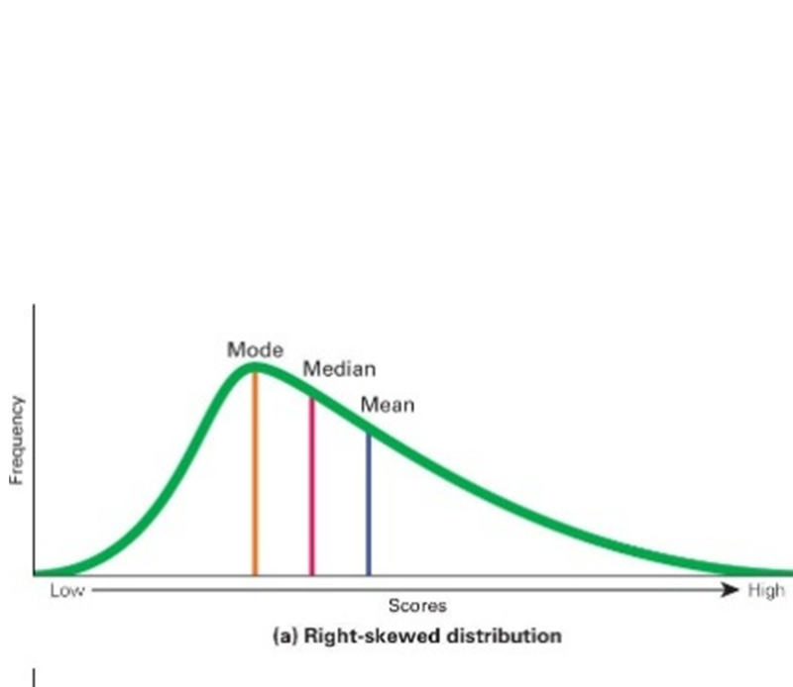

For a NORMAL Distribution, given a three-point range to estimate an activity duration of
- 10 days Optimistic (best case)
- 20 days Most Likely (ML) duration
- 70 days Pessimistic (worst case)

the graphic would appear with a Mean of 33.3 and a wide range as follows:

FIGURE 2
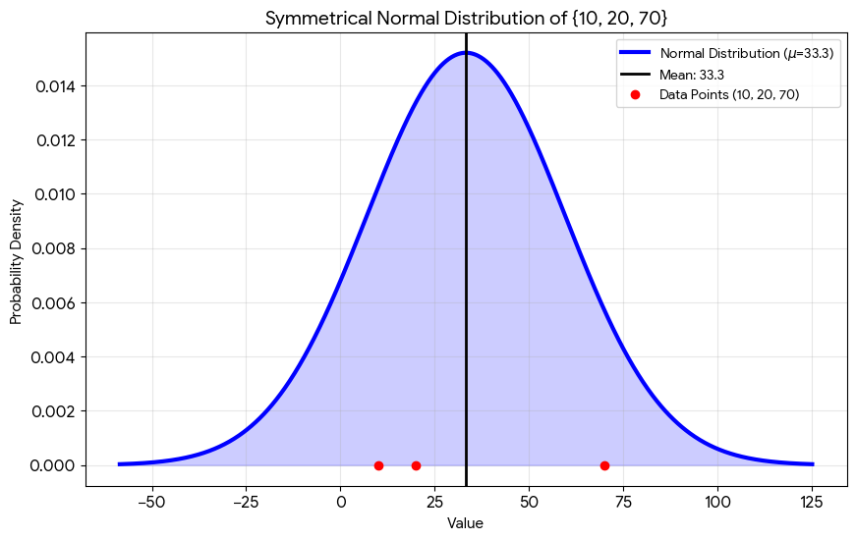

Employing the same three values, PERT has a couple of distinctively unique features:
- An apparently-arbitrary four-fold weighting of the Most Likely Value (ML)
- An Earliest Expected Time (EET) – i.e. the Mean derived from the weighted ML

After adjustment, the Resultant PERT is presented as a NORMAL distribution with a 26.67 EET:

FIGURE 3
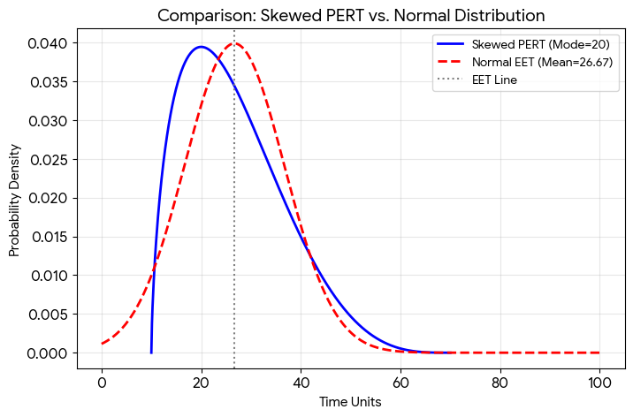

Furthermore, while retaining a symmetrical curve, rather than the unlimited range – and consequent larger Standard Deviation (33.3) -- as shown in Figure 2, another unique PERT feature is an ‘Estimated’ Standard Deviation that constricts the Standard Deviation to 1/6th of the Range, (10). Nevertheless, PERT still utilizes the ‘Normal’ statistical Z-Score probability table to estimate related activity duration probabilities.
The Effect is as follows:

- Dividing the range by 6 – to include the weighted ML values -- produces a Mean of lesser value; i.e. 26.67 vs 33.3.

- With the Mean (i.e. EET) closer to the Most Likely value, while distorting influence of outliers is partially reduced, other pessimistic probabilities are inflated and optimistic probabilities are deflated.

- The truncated Standard Deviation of 10 creates an analytical ‘straitjacket’ where the resulting probabilities are mostly confined to the original range under consideration, but which – concurrently -- heightens pessimistic span probabilities.

- Moreover, a key defect remains. Despite the skew, both optimistic & pessimistic probability values are still equally distributed on either side of the normal bell curve.

- The Net Effect of applying PERT is that optimistic probabilities are deflated while pessimistic probabilities for the same duration values are inflated.

- Furthermore – as indicated in my February article -- unfortunately, most PERT users tend to utilize the resultant EET ‘As is’, instead of recognizing its inherent risk as only a 50% probability. That misuse is like tossing a coin; or more dramatically, playing Russian Roulette with three bullets! [Hitherto, in order to rectify that error, my standing recommendation was to add 2 standard deviations to the EET for a result equal to a 95.44% probability, and 98% cumulative probability.]

The Remedy: To address the residual deflated optimistic probability span, and inflated pessimistic defect in PERT

- Initially, I conceived the overall right-skewed range distribution of Optimistic 10 days, Most Likely 20 days and Pessimistic 70 days, as two adjacent triangles in a rectangle. Example as illustrated in Figure 4:
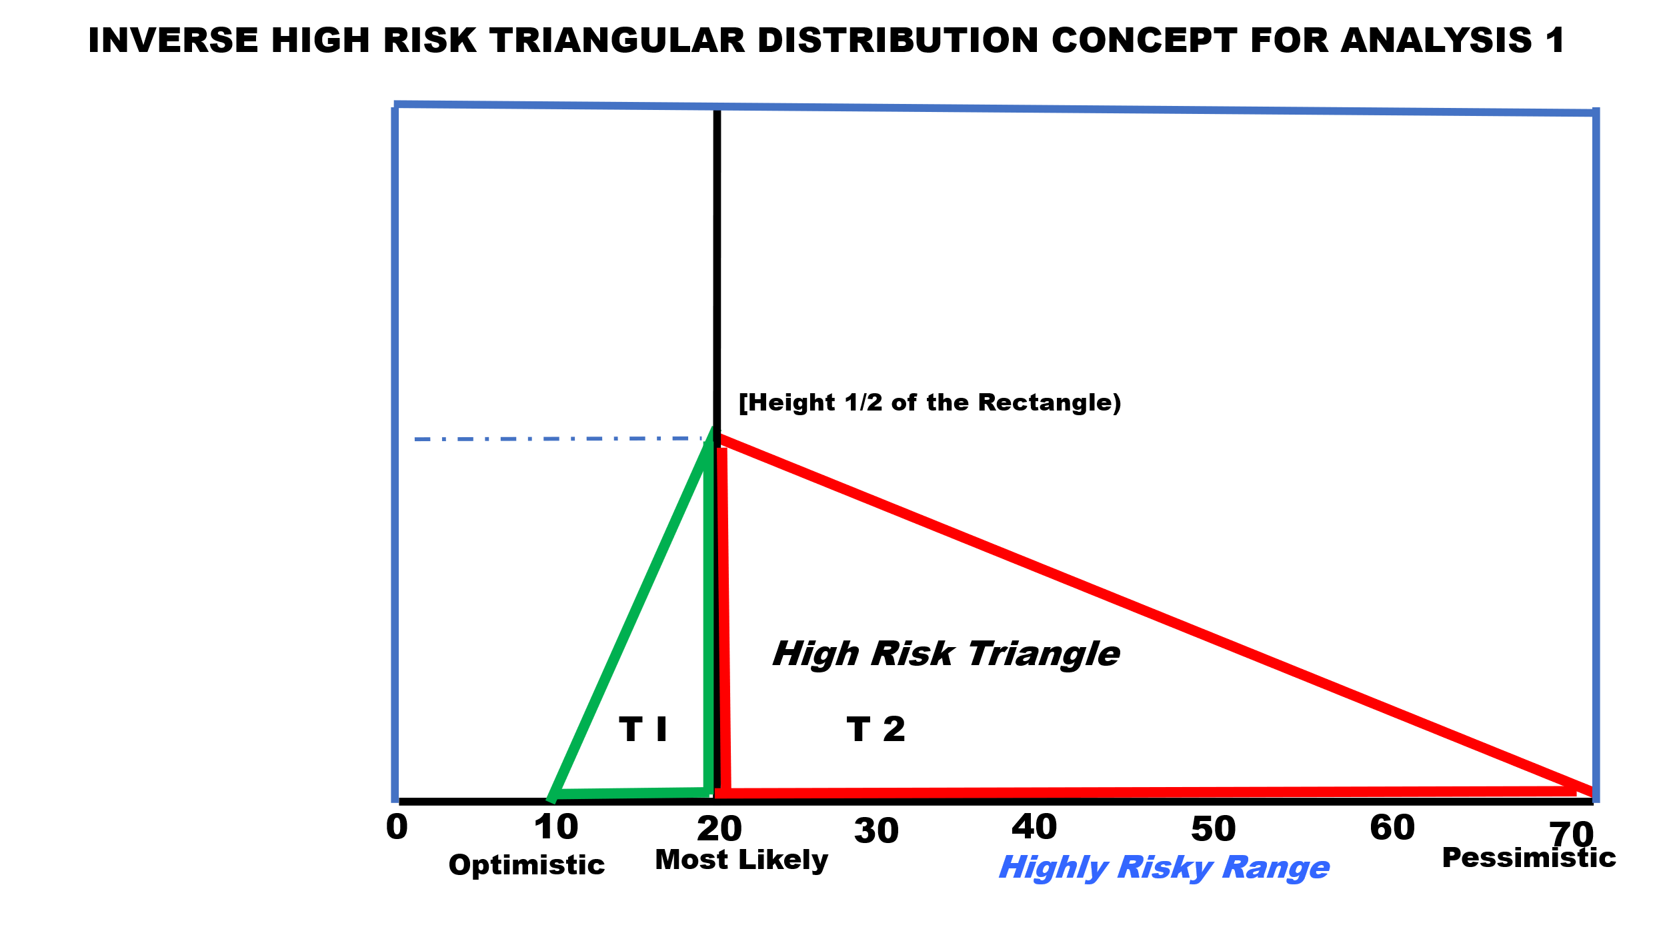
FIGURE 4
- Conceptually, I then flipped the High-Risk Triangle T2 to create a similar inverted ‘Ghost’, and added a probability scale to the rectangle to measure the cumulative probability of values in the T2 Triangle hypotenuse

FIGURE 5
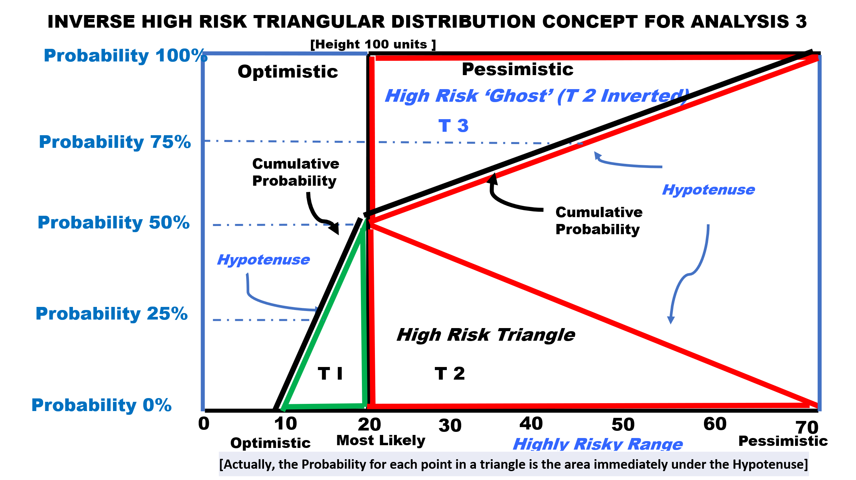

- Back to the actual triangles, I added ‘shoulders’ -- based on the optimistic skew probability of T1 -- to the common ‘Most Likely’ peak to emphasize their lop-sidedness,; as illustrated in Figure 6:

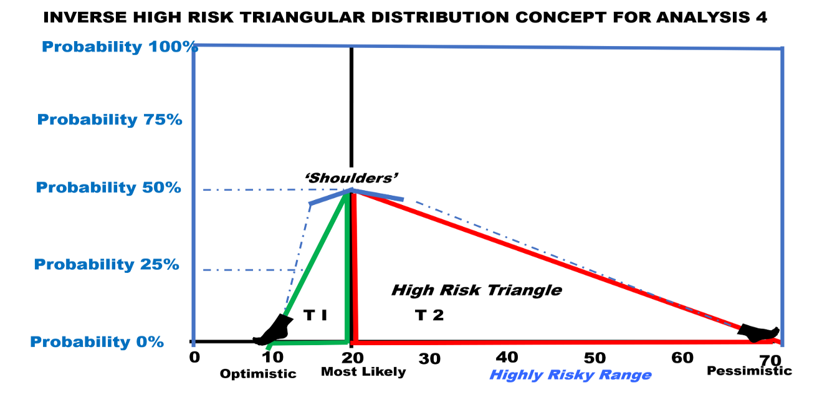
FIGURE 6
- The two triangles are then weighted so their ranges, standard deviations and probabilities can be computed separately:

  - Optimistic triangle T1: Subtract 1 from the Most Likely Value for a Median.
  - Pessimistic triangle T2: Add 1 to the Most Likely Value for a Median.

With 3 points, the triangles now have their own Mean and Standard Deviation, so I was able to rectify – to some extent -- the Probability distortions that result from either a single mean for the entire range with a symmetrical normal standard deviation dispersion, or the adjustment with a PERT EET.

- Utilizing a Normal Curve and Z-score probability table protocol a lop-sided ‘KENCURVE’ can then be obtained by combining the results of triangle 1 ‘Equal to, and Below’ the common original ‘Most Likely’ values, with the results of triangle 2 ‘Above the common original ‘Most Likely’ values

FIGURE 7
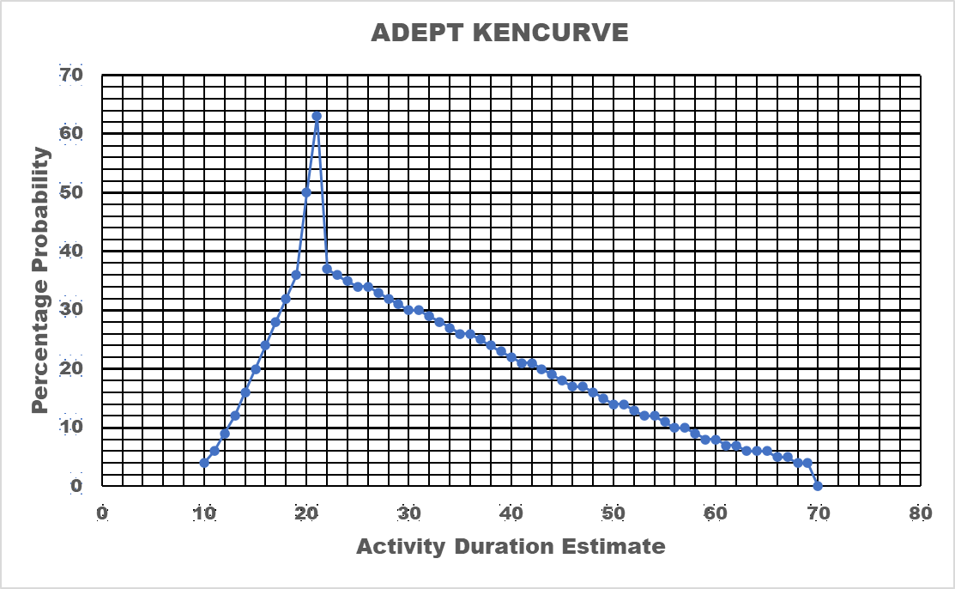

- The probabilities can also be identified for any value in the range and depicted in a continuous cumulative probability distribution

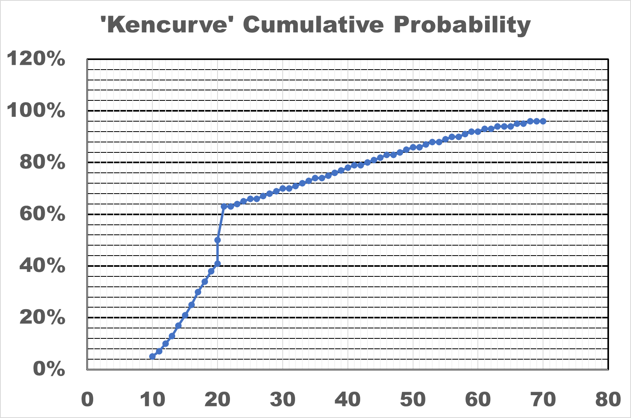
FIGURE 8

- While selection of any activity duration value to utilize is still subjective – based on planners judgements -- I still recommend 95% probability -- i.e. ‘two standard deviations -- as a desirable target for the activity duration; but in this instance 2 Standard Deviations beyond the Most Likely ‘shoulder’ value of Triangle 1, which will now appear as a lesser cumulative probability over the remainder of the Triangle 2 range.

- The improvements wrought by ADEPT compared to PERT – in terms of reflecting more realistic higher probabilities for the Optimistic range, and lower probabilities for the skewed Pessimistic range – are highlighted in Figure 9 on the following page

FIGURE 9
Comparative Probabilities for the Range of Selected Values

CONCLUSION

The foregoing analysis outlines Why and demonstrates How ADEPT is more realistic than PERT in addressing risky right-skew situations for deterministic activity duration estimating of probabilities. Furthermore, my template in Figure 10 can facilitate ADEPT application by crunching the numbers for you.

FIGURE 10
The template is designed for up to 400 activities.

Here’s the link; Hold the Control key, and click on the logo to download it.
Try it; You’ll like it!
Caution & Common Sense
No matter how hard we try to understand the components, tools and techniques of project management and apply them with logic, systematic approaches and quantitative formulations; remember implementation of projects is in a messy VUCA environment, and we can still go wrong, systematically!
About the Author

Dr. Kenneth Smith
Honolulu, Hawaii
& Manila, The Philippines

Initially a US Civil Service Management Intern, then a management analyst & systems specialist with the US Defense Department, Ken subsequently had a career as a senior foreign service officer -- management & evaluation specialist, project manager, and in-house facilitator/trainer -- with the US Agency for International Development (USAID). Ken assisted host country governments in many countries to plan, monitor and evaluate projects in various technical sectors; working ‘hands-on’ with their officers as well as other USAID personnel, contractors and NGOs. Intermittently, he was also a team leader &/or team member to conduct project, program & and country-level portfolio analyses and evaluations.

Concurrently, Ken had an active dual career as Air Force ready-reservist in Asia (Japan, Korea, Vietnam, Indonesia, Philippines) as well as the Washington D.C. area; was Chairman of a Congressional Services Academy Advisory Board (SAAB); and had additional duties as an Air Force Academy Liaison Officer. He retired as a ‘bird’ colonel. After retirement from USAID, Ken was a project management consultant for ADB, the World Bank, UNDP and USAID.

He earned his DPA (Doctor of Public Administration) from the George Mason University (GMU) in Virginia, his MS from Massachusetts Institute of Technology (MIT Systems Analysis Fellow, Center for Advanced Engineering Study), and BA & MA degrees in Government & International Relations from the University of Connecticut (UCONN). A long-time member of the Project Management Institute (PMI) and IPMA-USA, Ken is a Certified Project Management Professional (PMP®) and a member of the PMI®-Honolulu and Philippines Chapters.

Ken has two KENBOOKS: 1. Project Management PRAXIS which includes many innovative project management tools & techniques; and describes a “Toolkit” of related templates, and 2. MUSINGS on Project Management -- a compilation of contemporary concerns in project planning, monitoring & evaluation, with some tools & techniques suggested for their solution. Either or both books are available from Amazon, and their related templates are available directly from him at kenfsmith@aol.com on proof of purchase.

To view other works by Ken Smith, visit his author showcase in the PM World Library at https://pmworldlibrary.net/authors/dr-kenneth-smith/

How to cite this article: Smith, K.F. (2026). Better than PERT? You’d Better Believe! It’s More ADEPT. PM World Journal, Vol. XV, Issue V, May
ADEPT: Activity Duration Estimating with Probability Triangulation
Smith, K.F. (2026). In Defense of PERT-PLUS. PM World Journal, Vol. XV, Issue II, February
NOTE: Utilizing the common ‘Most Likely’ value in each triangle, as well as a ‘plus-up’ and ‘plus-down’ effectively incurs the overall range being weighted by a factor of four – i.e. the same weighting utilized by PERT! So perhaps PERT’s weighting was not arbitrary after all.
Nevertheless, the probabilities of both triangle laterals – i.e. their hypotenuses -- are still equally distributed from their respective means, instead of skewed; so rather than perfect, my modification to PERT only partially rectifies the distortion.
Volatility, Uncertainty, Complexity, and Ambiguity,

